**NTSBE-91**

**SOIDelta Partners - Create Most Used Data BTS and Most Used Voice BTS - Daily Aggregation**

**Analyzed By:** Sarvani A

**Designed By:** Sarvani A

## Overview:

Fidelity Partners analyst needs to know which BTS(ENB) the customer used the most for Data usage and which BTS(ENB) the customer used the most for Voice usage for a calendar month. This data needs to be delivered to Omega server (SOI) and will be masked before being transferred to Delta Partners.

This task will take KPIs from LTE_SDR dataset and aggregate them once in a day.

## Internal/External Impacts:

N/A

## Assumptions:

N/A

## Detailed Design:

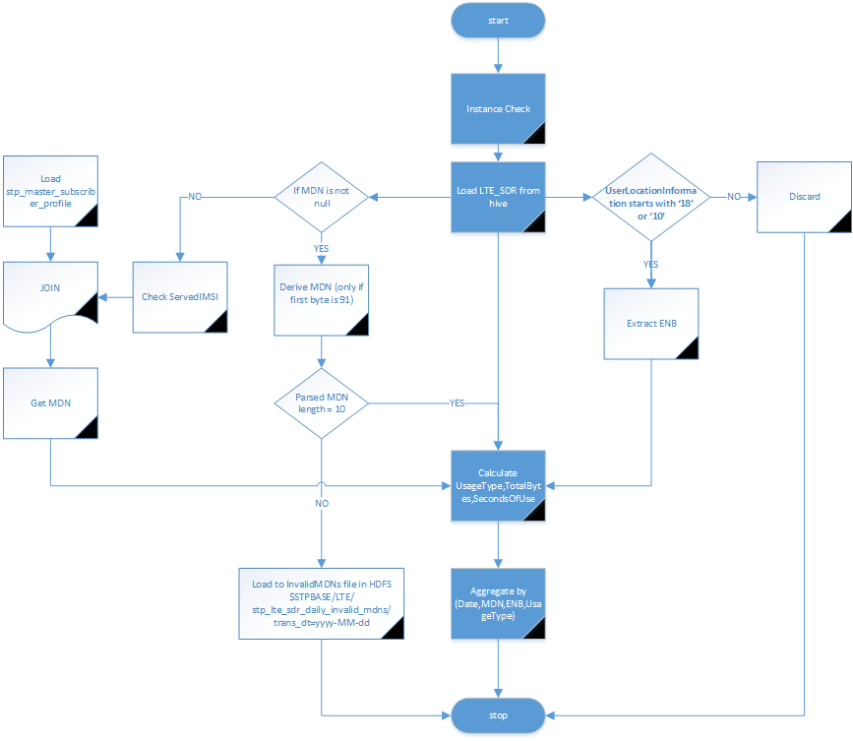

### Input Changes:

*Datatypes TBU

#RecordType

SourceFilename

ServedIMSI

IMSI_MCC_MNC

ServedMSISDN

StartTime

StopTime

ServedPDPPDNAddress

PDPPDNType

DynamicAddressFlag

LocalSequenceNumber

RecordSequenceNumber

CauseForRecClosing

ManufacturerSpecificCauseForDiagnositcs

ChargingID

RATType

MSTimeZone

ThreeGPP2UserLocationInformation

UserLocationInformation

ServedIMEISV

Served3gpp2MEID

Served3gpp2ESN

ServingNodePLMNIdentifier

ChargingGroupId

AccessPointNameNI

APNSelectionMode

ChargingCharacteristics

chChSelectionMode

PGWAddress

p-GWPLMNIdentifier

ServingNodeAddress

NodeID

ServingNodeType

ChargingGatewayFunctionHost

Retransmission

ACRStartLost

ACRInterimLost

ACRStopLost

ListOfServiceData(RatingGroup;AFChargingIdentifier;FromMobileBytes;ToMobileBytes;TimeOfFirstUsage;TimeOfLastUsage;ServiceConditionChange;QoS-Class-Identifier;BearerChargingID;APNAggregateMaxBitrateUL;APNAggregateMaxBitrateDL)

UserEquipmentValue

UserEquipmentType

SessionDuration

SessionStartTime

### Logic:

1. Load LTE_SDR dataset from Hive table
2. Filter and parse required fields as shown below.

|  |  |  |  |
| --- | --- | --- | --- |
| **Source Field** | **Destination Field** | **Logic** | **Daily Aggregation** |
|  | **Date** | mmddyyyy | Aggregate per Date/MDN/ENB/UsageType (Can use SessionStartTime) |
| ServedMSISDN | MDN | Refer 1.4.2[3] | Aggregate per Date/MDN/ENB/UsageType |
| UserLocationInformation | ENB | Refer 1.4.2[4] | Aggregate per Date/MDN/ENB/UsageType |
| ListOfServiceData(FromMobileBytes)* | UsageType | IF PDN in ( ‘Usage Segmentation’,  ‘Go90 – Legacy’, ‘NFL app’, ‘Go90- NFL Live stream – Legacy’, ‘Go90 New Version’,  ‘VzW Messages’) then ignore the record.  IF PDN in (vzwims, ims) AND RatingGroup in (102, 103, 104, 105, 109) then ‘Voice’ ELSE ‘Data’ | Aggregate per Date/MDN/ENB/UsageType |
| ListOfServiceData(TimeOfFirstUsage;TimeOfLastUsage)* | TotalMobileBytes | FromMobileBytes+ToMobileBytes | For Voice: Null For Data: SUM(TotalMobileBytes) |
| ListOfServiceData(TimeOfFirstUsage;TimeOfLastUsage)* | SecondsOfUse | Decypher timestamp format and Convert to seconds (TimeOfLastUsage - TimeOfFirstUsage) | For Voice: SUM(SecondsOfUse)  For Data: Null |

1. Parse Logic for MDN:

If ServedMSISDN is not null, then

Check if number starts with +91, if not, discard record

If yes, let’s say +918123550534f4 is servedMSISDN

Before transformation: +91 81 23 55 05 34 f4

After nibble mapping: +91 18 32 55 50 43 4f

Discard unnecessary chars: 8 32 55 50 43 4 (MDN)

If no.of digits Matches 10, It’s a valid MDN else, discard.

If ServedMSISDN is null, then

Check non-null ServedIMSI

Get MDN by ServedIMSI from stp_master_subscriber_profile

1. Parse Logic for enodeB:

If USerLocationInformation starts with ‘18’,

Example: 18 130184 f20a 130184 0 3b1ab 20

Convert 3b1ab [hex] 🡪 242091 [dec]

091 – EnodeB

If UserLocationInformation starts with ‘10’

Example: 10 130 184 0 3dd12 02

Convert 3dd12 [hex] 🡪 253202 [dec]

202 – EnodeB

1. Aggregate by (Date,MDN,ENB,UsageType)

### Output Changes:

**HDFS File Location:**

$STPBASE/LTE/stp_lte_sdr_agg_daily/trans_dt=yyyy-MM-dd

**Stp_lte_sdr_agg_daily:**

|  |  |
| --- | --- |
| **Column** | **DataType** |
| Trans_dt | String |
| Mdn | String |
| Enb | String |
| UsageType | String |
| TotalMobileBytes | long |
| Secondsofuse | long |

## Run Time Information:

### Executable/Script name and command line options to run:

scripts/stp_lte_sdr_agg_daily.pig

scripts/stp_lte_sdr_agg_daily.sh

config/load_stp_config.cfg

### Configuration / Environment Settings Required:

TBD

### Log messages to expect – Format and Action to be taken:

TBD

### Run Time Frequency:

Daily once

### Configuration Information:

config/load_stp_config.cfg

## Configuration Management Information:

N/A

## Security Exposure Review:

N/A

## Unit Test Cases:

|  |  |  |  |
| --- | --- | --- | --- |
| **Sl. No** | **Test Case Description** | **Expected Results** | **Test Case Status** |
| 1 | Check if parsing logic is proper for all output columns | MDN,ENB,UsageType,TotalBytes,SecondsOfUse  Should be updated accor.to Section 1.4.2 | TBU |
| 2 | Check if records aggregated by (date,mdn,enb,usagetype) | Should not have duplicates by (date,mdn,enb,usagetype) | TBU |

## Issues

|  |  |  |  |
| --- | --- | --- | --- |
| **Sl. No** | **Description** | **Status** | **Owner** |
|  |  |  |  |